Project Report

TEAM ID: LTVIP2026TMIDS41306

# INTRODUCTION:

* 1. **Project Overview**

The **Electricity Consumption Insights and Trend Analysis** project aims to study and visualize electricity usage patterns across different regions and time periods using **Tableau**. The project analyzes large datasets related to electricity consumption to identify trends, seasonal variations, and demand patterns. By converting raw data into **interactive dashboards and visual reports**, the project helps in understanding how electricity is consumed across regions, time frames, and usage categories. This visual approach simplifies complex data and enables stakeholders to gain insights quickly and effectively.

The primary purpose of this project is to assist **energy analysts, policymakers, utility providers, and decision-makers** in understanding electricity consumption behavior. Using a data-driven approach, the project allows users to explore consumption trends, peak demand periods, and regional variations. These insights support better decision-making in areas such as **energy planning, demand forecasting, resource optimization, and policy formulation**, ultimately contributing to efficient and sustainable energy management.

# IDEATION PHASE

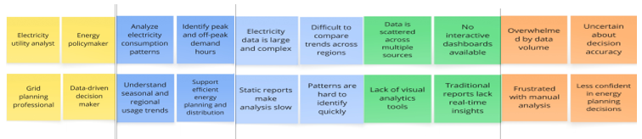 **2.1 Problem Statement**

**Customer problem statement**

|  |  |  |  |  |  |
| --- | --- | --- | --- | --- | --- |
| **Problem Statement (PS)** | **I am (Customer)** | **I’m trying to** | **But** | **Because** | **Which makes me feel** |
| PS-1 | an electricity utility analyst | identify peak electricity demand patterns | data is scattered and complex | there’s no unified visual dashboard | unsure about demand planning |
| PS-2 | an energy policymaker | track regional electricity consumption trends | I can’t compare trends easily | dashboards aren’t interactive | frustrated and uncertain |

**2.2 Empathy Map Canvas**

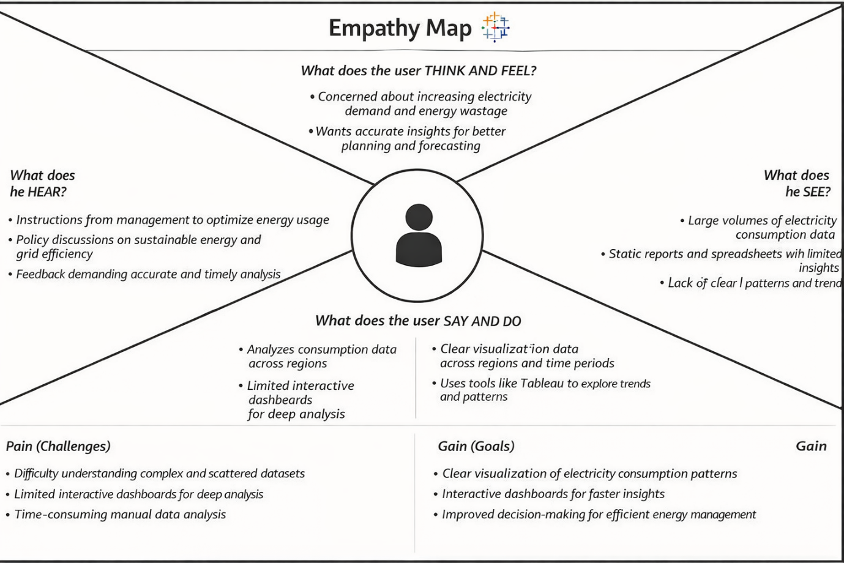

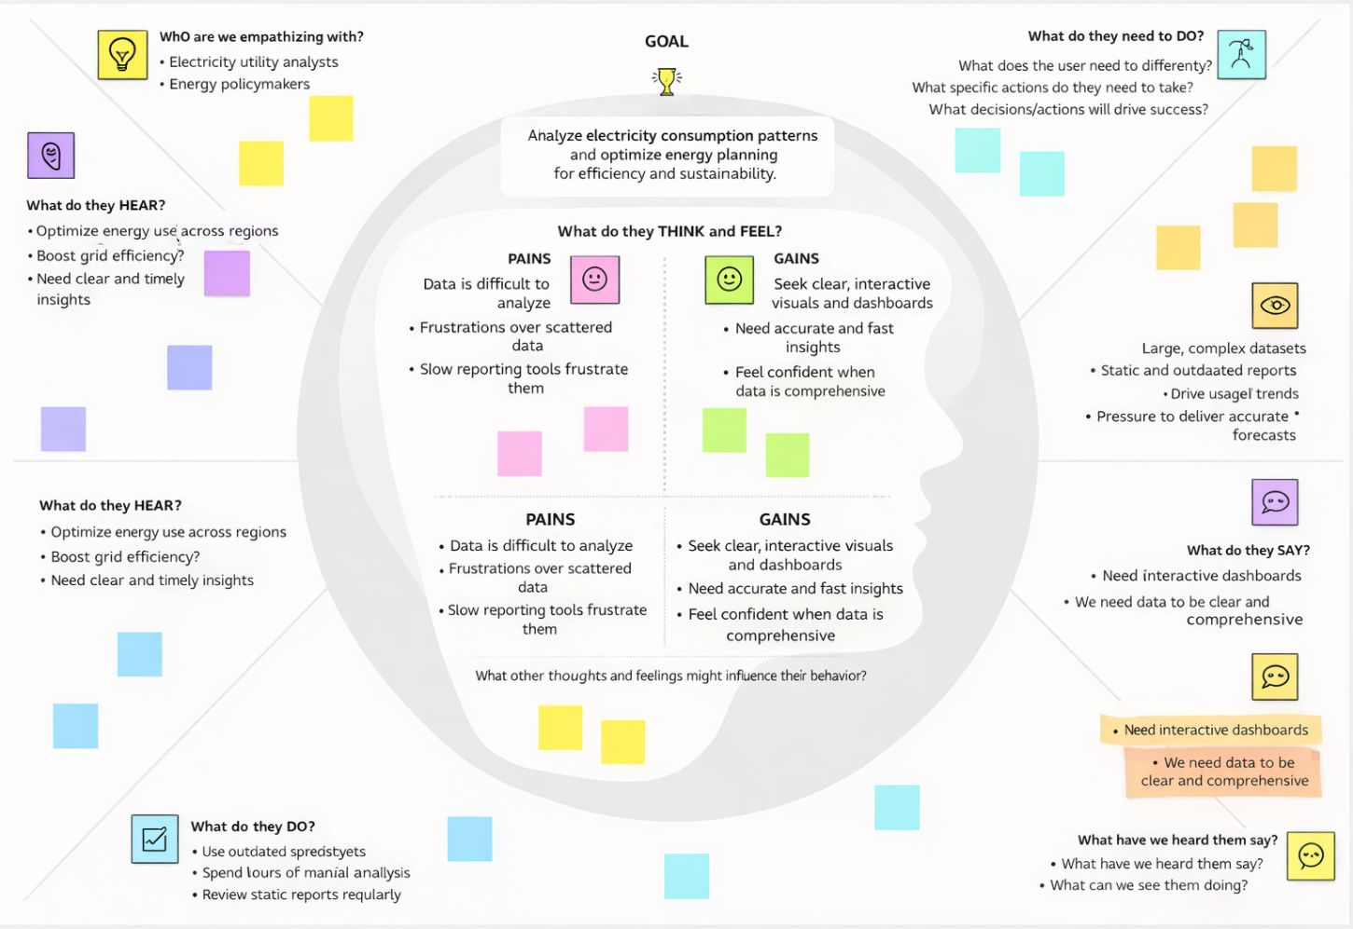

* 1. **Brainstorming**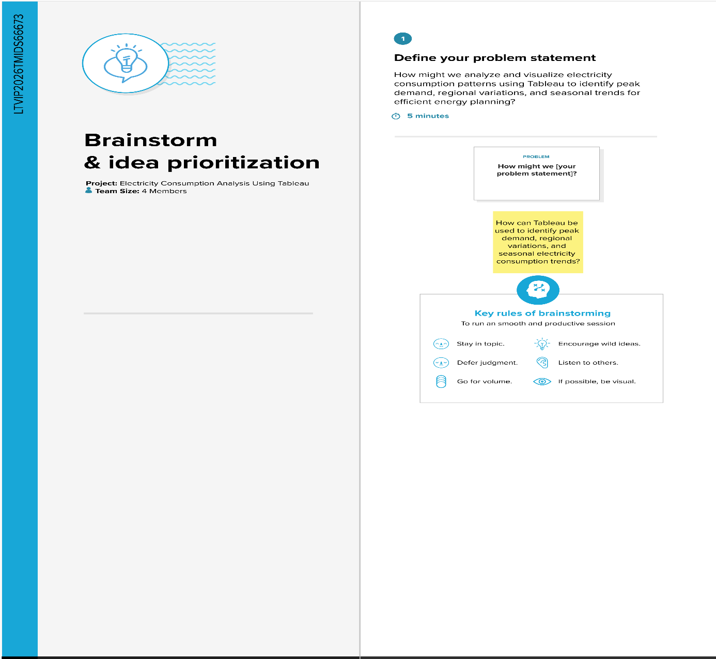

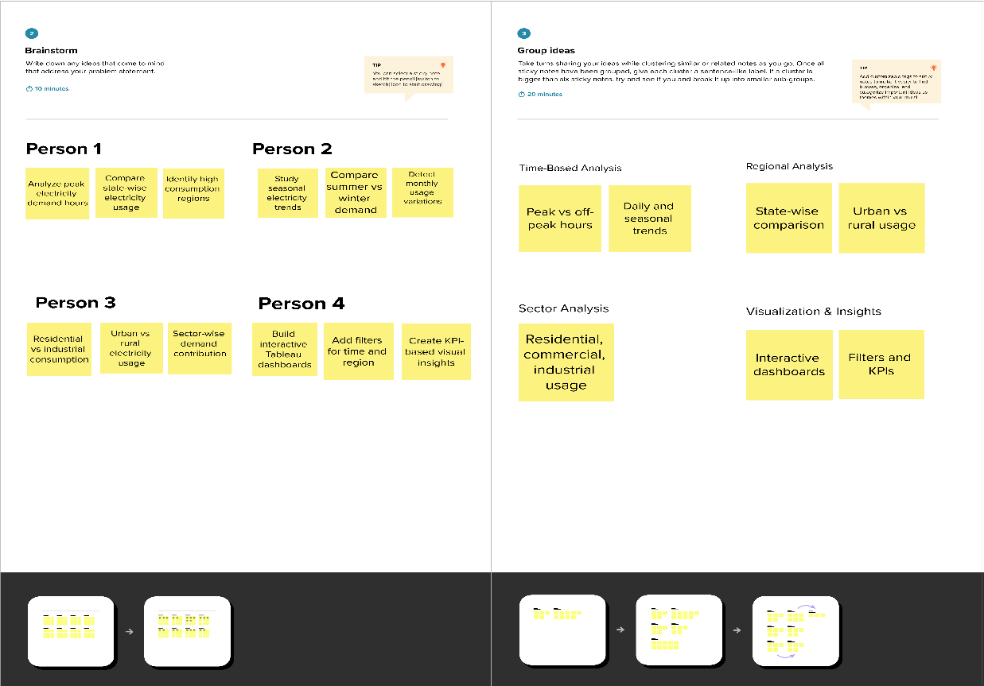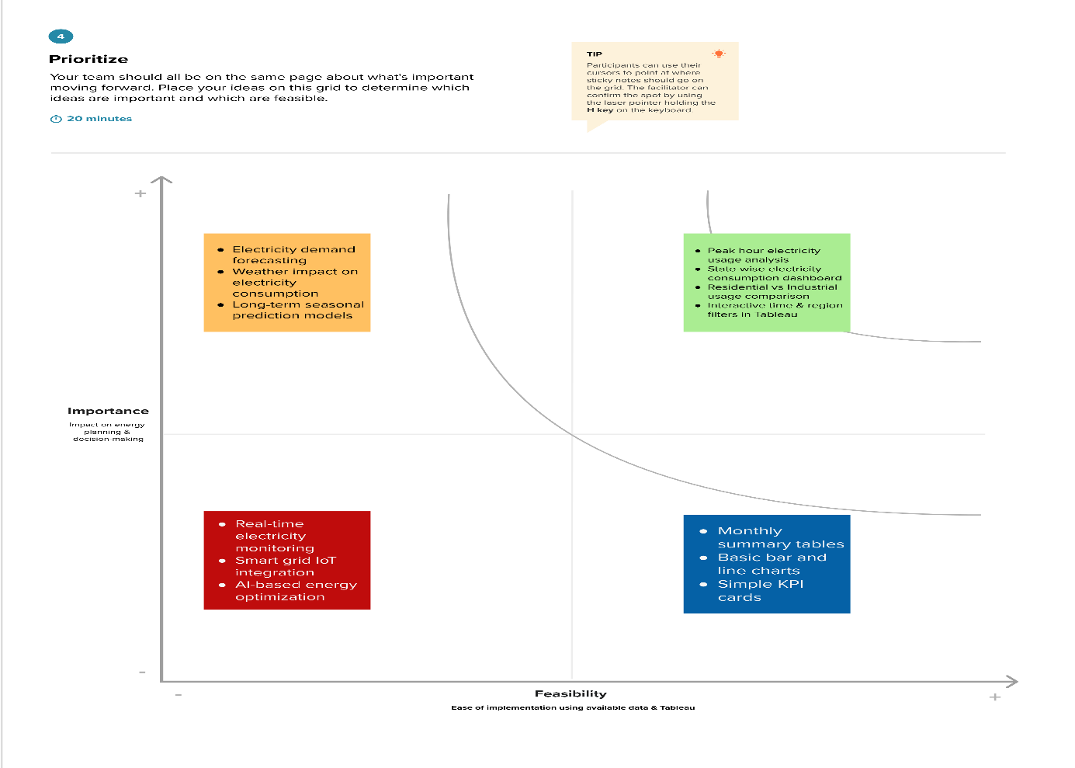

# 3. REQUIREMENT ANALYSIS

**3.1 Customer Journey map**

|  |  |  |  |  |  |
| --- | --- | --- | --- | --- | --- |
| Stage | Need | Action | Touchpoint | Pain Point | Opportunity |
| Discover | Wants iPhone market trends | Searches Excel/market data | Emails, Files | Data is scattered | Single dashboard entry point |
| Explore | Needs regional & feature insights | Browses charts manually | Spreadsheets, BI tools | Time-consum ing | Filter-enabled Tableau dashboard |
| Engage | Wants to compare specs vs pricing | Tries custom visualizations | Excel formulas | Lacks interactivity | Pre-built price/spec dashboard |
| Decide | Prepares pitch for leadership | Screenshots graphs | Presentations | Dry data storytelling | Use Tableau story points with captions |

**3.2 Solution Requirement**

**Functional Requirements:**

|  |  |  |
| --- | --- | --- |
| **FR No.** | **Functional Requirement (Epic)** | **Sub Requirement (Story / Sub-Task)** |
| FR-1 | |  | | --- | | User Authentication |  |  | | --- | |  | | |  | | --- | | User login through username & password |  |  | | --- | |  | |
| FR-2 | |  | | --- | | Data Upload |  |  | | --- | |  | | |  | | --- | | Upload electricity consumption datasets (CSV/Excel) |  |  | | --- | |  | |
| FR-3 | |  | | --- | | Data Validation |  |  | | --- | |  | | |  | | --- | | Validate missing values and incorrect data |  |  | | --- | |  | |
| FR-4 | |  | | --- | | Data Processing |  |  | | --- | |  | | |  | | --- | | Process data using Flask backend |  |  | | --- | |  | |
| FR-6 | |  | | --- | | Data Visualization |  |  | | --- | |  | | |  | | --- | | Generate interactive Tableau dashboards |  |  | | --- | |  | |
| FR-5 | |  | | --- | | Data Storage |  |  | | --- | |  | | |  | | --- | | Store processed data in database |  |  | | --- | |  | |

**3.3 Data Flow Diagram**

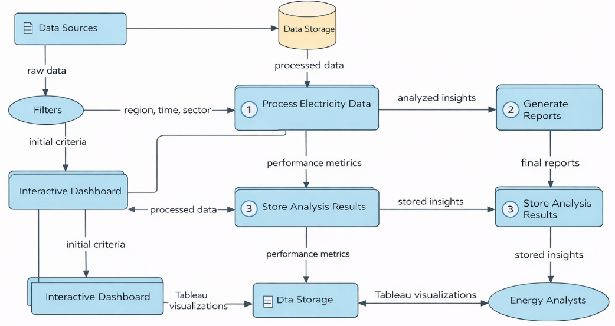

* 1. **Technology Stack**

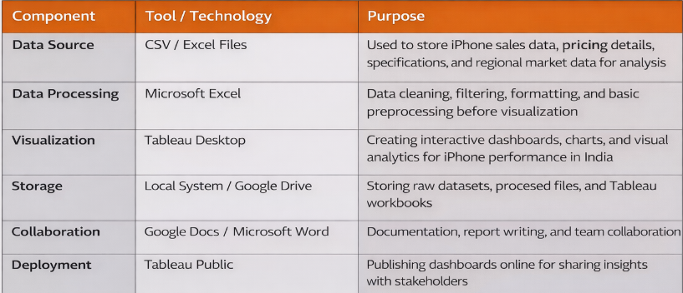

1. **PROJECT DESIGN**
   1. **Problem Solution Fit  
        
      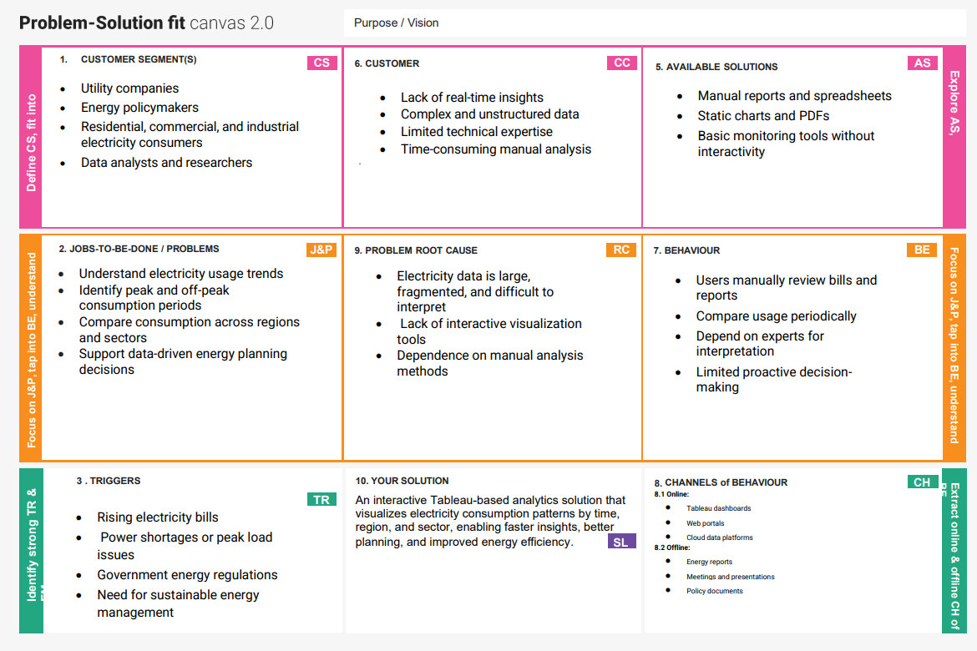**
2. **Proposed Solution**

|  |  |  |
| --- | --- | --- |
| **S.No.** | **Parameter** | **Description** |
|  | Problem Statement (Problem to be solved) | Manual analysis of electricity consumption data is time-consuming and does not clearly reveal peak demand, seasonal trends, or regional usage patterns, making efficient energy planning difficult. |
|  | Idea / Solution description | |  | | --- | | The solution analyzes electricity consumption data using Python and visualizes insights through interactive Tableau dashboards to identify peak demand, seasonal trends, and regional variations. |  |  | | --- | |  | |
|  | Novelty / Uniqueness | |  | | --- | | Integrates automated data processing with interactive Tableau dashboards, allowing users to dynamically explore electricity usage without technical expertise. |  |  | | --- | |  | |
|  | Social Impact / Customer Satisfaction | |  | | --- | | Helps energy providers and policymakers optimize electricity usage, reduce wastage, and improve planning, resulting in better service reliability and customer awareness. |  |  | | --- | |  | |
|  | Business Model (Revenue Model) | |  | | --- | | Offered as a subscription-based dashboard, licensed analytics tool for energy agencies, or a consulting solution for electricity consumption analysis. |  |  | | --- | |  | |
|  | Scalability of the Solution | Scalable architecture supports large datasets, cloud storage, and future integration of additional regions, years, or real-time electricity data. |

# 4.3 Solution planning

# 5. PROJECT PLANNING & SCHEDULING

* 1. **Project Planning**

| **Sprint** | **Functional Requirement (Epic)** | **User Story Number** | **User Story / Task** | **Story Points** | **Priority** | **Team Members** |
| --- | --- | --- | --- | --- | --- | --- |
| Sprint-1 | |  | | --- | |  |  |  | | --- | | Data Collection | | USN-1 | as user, I can upload electricity consumption datasets (CSV/Excel) into the system. | 2 | High | Member-1 |
| Sprint-1 | |  | | --- | |  |  |  | | --- | | Data Pre-processing | | USN-2 | |  | | --- | | As a user, I want the system to clean and preprocess raw electricity data automatically. |  |  | | --- | |  | | 2 | High | Member-2 |
| Sprint-1 | |  | | --- | | Data Storage |  |  | | --- | |  | | USN-3 | |  | | --- | | As a user, I want the processed data to be stored securely for analysis. |  |  | | --- | |  | | 1 | Medium | |  | | --- | |  |  |  | | --- | | Member-3 | |
| Sprint-2 | |  | | --- | | Data Analysis |  |  | | --- | |  | | USN-4 | |  | | --- | | As a user, I can analyze electricity consumption trends such as peak demand and seasonal patterns. |  |  | | --- | |  | | 3 | High | Member-1 |
| Sprint-2 | Visualization | USN-5 | |  | | --- | | As a user, I can view interactive dashboards in Tableau for better insights. |  |  | | --- | |  | | 3 | High | Member-2 |
| Sprint-2 | |  | | --- | | Dashboard Filters |  |  | | --- | |  | | USN-6 | |  | | --- | | As a user, I can filter data by region, time period, and consumption type. |  |  | | --- | |  | | 2 | Medium | Member-4 |
| Sprint-3 | |  | | --- | | Performance Optimization |  |  | | --- | |  | | USN-7 | |  | | --- | | As a user, I want dashboards to load quickly even for large datasets. |  |  | | --- | |  | | 2 | Medium | |  | | --- | |  |  |  | | --- | | Member-3 | |
| Sprint-3 | |  | | --- | | Reporting |  |  | | --- | |  | | USN-8 | |  | | --- | | As a user, I can export visualizations and reports for decision-making. |  |  | | --- | |  | | 1 | Low | Member-4 |

# FUNCTIONAL AND PERFORMANCE TESTING

* 1. **Performance Testing**

|  |  |  |
| --- | --- | --- |
| **S.No.** | **Parameter** | **Screenshot / Values** |
|  | Data Rendered | |  | | --- | | Electricity consumption dataset loaded successfully into  Tableau with multiple dimensions (Date, Region,  Consumption Type) and measures (Units Consumed). |  |  | | --- | |  | |
|  | Data Preprocessing | |  | | --- | | Data cleaning performed: null values handled, date  formats standardized, unnecessary columns removed,  and data aggregated at monthly and regional levels. |  |  | | --- | |  | |
| 3. | Utilization of Filters | |  | | --- | | Data cleaning performed: null values handled, date  formats standardized, unnecessary columns removed,  and data aggregated at monthly and regional levels. |  |  | | --- | |  | |
| 4. | Calculation fields Used | |  | | --- | | Data cleaning performed: null values handled, date formats standardized, unnecessary columns removed, and data aggregated at monthly and regional levels. |  |  | | --- | |  | |
| 5. | Dashboard design | No of Visualizations / Graphs - **6** (Bar Chart, Line Chart, Heat Map, KPI Cards, Pie Chart, Trend Analysis). |
| 6 | Story Design | No of Visualizations / Graphs -: **4** (Consumption Trends, Regional Comparison, Seasonal Patterns, Key Insights Summary). |

**7. RESULTS**

**7.1 Output screenshots**

**Dashboards**

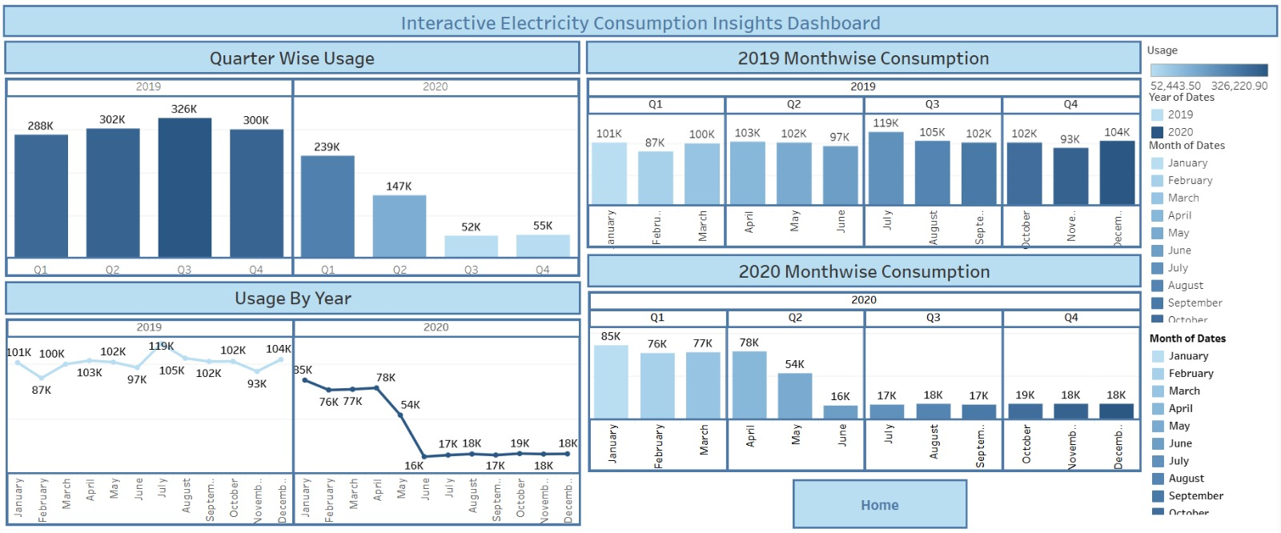

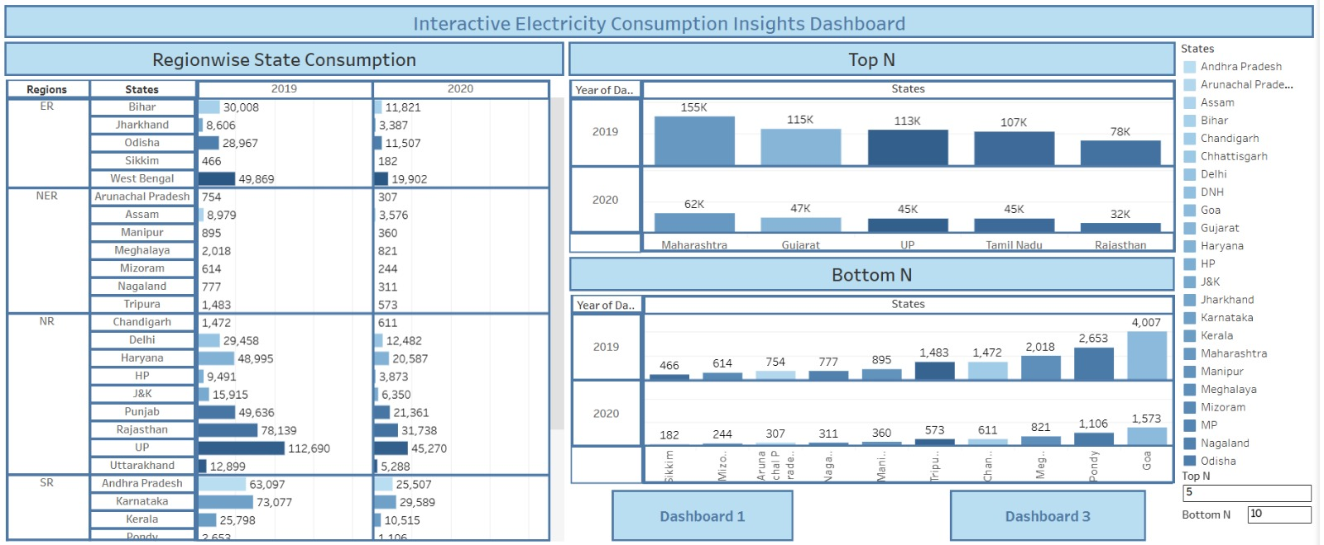

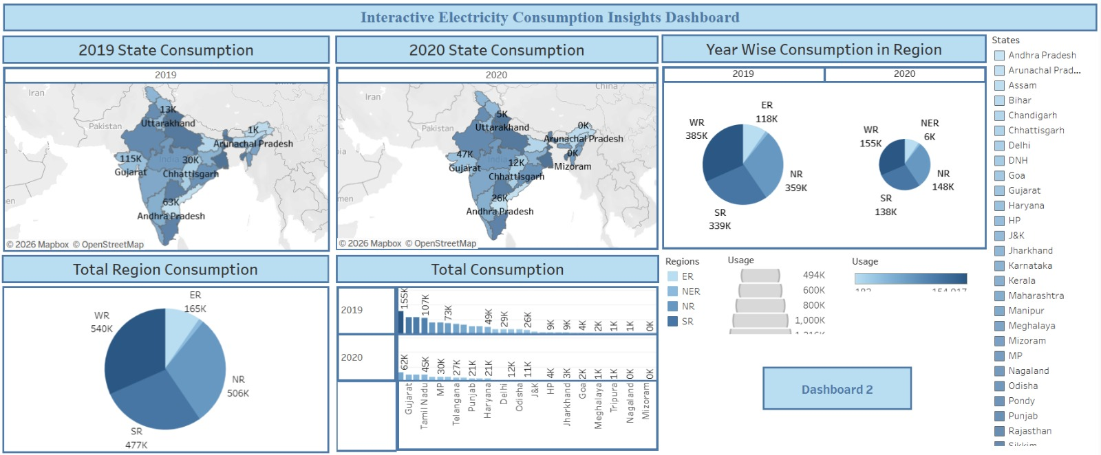

**STORY OUTPUTS:**

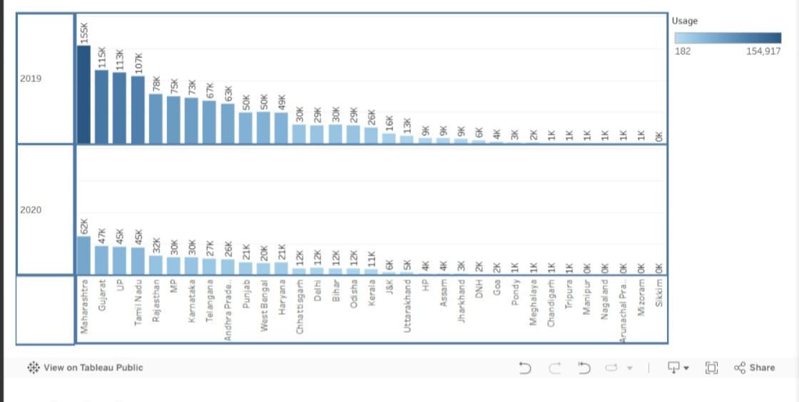

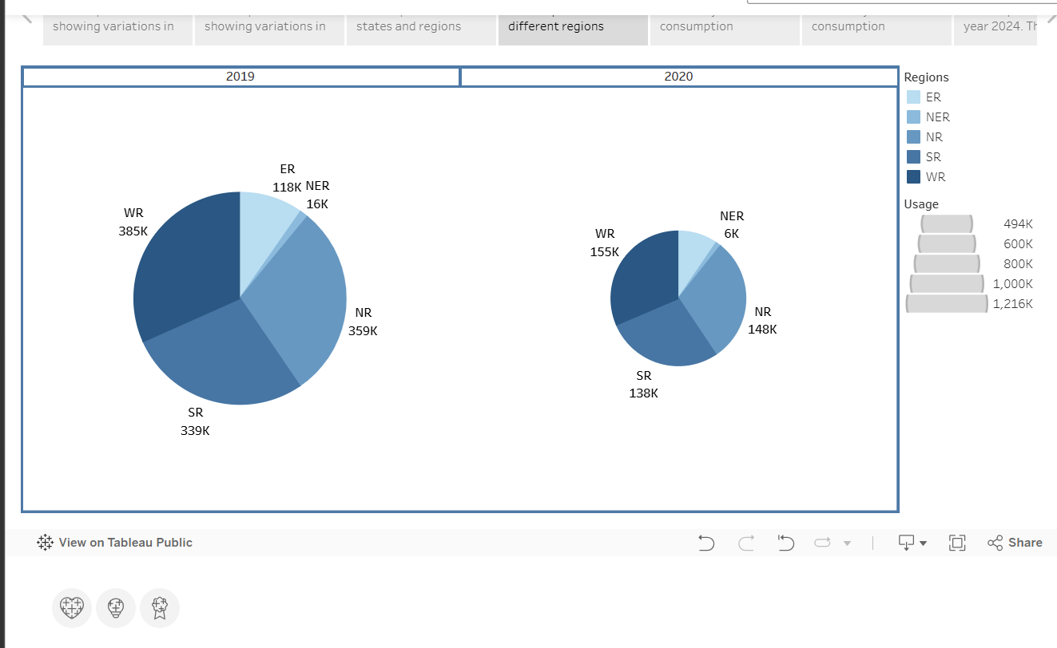

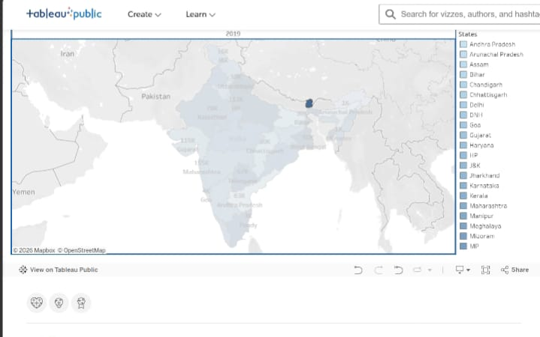

**Advantages**

1. **Interactive Data Visualization**The project uses Tableau to convert complex electricity datasets into interactive dashboards, making analysis simple and user-friendly.
2. **Improved Decision Making**  
   Helps utility providers and policymakers make informed decisions regarding energy planning and demand forecasting.
3. **Identification of Peak Demand**  
   Easily detects peak usage hours, seasonal trends, and regional consumption differences.
4. **Time-Saving**  
   Automates data cleaning and processing using Python and Flask backend, reducing manual work.
5. **Scalable Architecture**  
   Can handle large datasets and can be expanded to include additional years, regions, or sectors.
6. **Better Resource Optimization**  
   Assists in reducing electricity wastage and improving load distribution strategies.
7. **User-Friendly Dashboard**  
   Filter-enabled dashboards allow users to analysis data by region, time, and consumption type.

**Disadvantages**

1. **Dependency on Data Quality**Incorrect or incomplete datasets can lead to misleading results.
2. **No Real-Time Data (Current Version)**The project mainly works with historical data, not live electricity consumption data.
3. **Initial Setup Complexity**Integration of Python backend, database, and Tableau requires technical knowledge.
4. **Performance Issues with Extremely Large Datasets**Without optimization, dashboard loading time may increase.
5. **Limited Predictive Analytics**Current project focuses more on visualization than advanced AI-based forecasting.

**Conclusion**

* The project Interactive Dashboards for Electricity Consumption Insights and Trend Analysis successfully demonstrates how data analytics and visualization tools can transform raw electricity consumption data into meaningful insights.
* By integrating automated data processing with interactive dashboards in Tableau, the system enables stakeholders to identify peak demand periods, seasonal variations, and regional consumption trends effectively.
* This project enhances decision-making capabilities for energy providers and policymakers, supporting efficient energy planning, optimized resource allocation, and sustainable electricity management.
* Overall, the project proves that data-driven visualization plays a crucial role in modern energy management systems.

**Future Scope**

1. **Real-Time Data Integration**  
   Connect the dashboard with smart meters or IoT devices to analyze live electricity consumption.
2. **AI-Based Demand Forecasting**  
   Integrate Machine Learning models for accurate electricity demand prediction.
3. **Cloud Deployment**  
   Deploy dashboards on cloud platforms like Tableau Server or Microsoft Azure for remote access.
4. **Mobile Dashboard Version**  
   Develop mobile-friendly dashboards for quick access by field officers.
5. **Integration with Renewable Energy Data**  
   Include solar and wind energy production data to compare renewable contribution.
6. **Automated Alert System**  
   Implement alerts for abnormal consumption spikes.
7. **Advanced Analytics Features**  
   Add predictive modeling, anomaly detection, and energy optimization recommendations.